Ambient Systems
Singapore | Hong Kong
www.ambientsystems.ai

Product Brochure
Apr 22, 2024

Product Overview
Ambient Systems provides a turnkey solution for vertical farm operators who need to enhance their financial performance by helping you simulate the optimal climate conditions for expected crop yields.

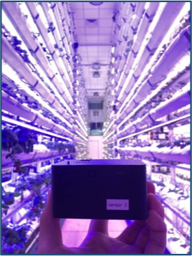
Benefits
The solution can help you achieve a range of benefits, including +24% increase in energy savings, man-hour savings, enhanced crop performance.
Farmers can expect to see positive results and break-even after 4-6 months.

Ambient Systems is for specialized vertical farms
You can deploy Ambient Systems in any type of indoor farming environment, from purpose-built farming plants to refurbished facilities and containerized farming.

Process
You can easily combine the data available from your on-site operations with your existing online digital management systems. From there, you will be guided through a series of simple steps to prepare and organize the data, making it accessible to you for analysis. Finally, you’ll be able to access a fully tailored AI model to improve your climate conditions to improve the crop yield while reducing chances of crop failure due to disease, pests, and other externalities.

Pricing
You can access the offering from three different options.
- Option 1: Subscription (pricing TBC)
  - Cloud-based Software
  - Cross-platform: Mac, Linux, Windows
  - Data Types Supported:
    - Finance Data
    - ERP Data
    - Documents
  - AI-supported data integration (identify opportunities to improve data quality)
  - AI-supported financial goal setting (identify areas for improvement)
  - AI-supported financial planning (generate future projections with ease)
- Option 2: AI Software Implementation (pricing TBC)
  - ETL Process
  - Custom AI Model:
    - BMS Climate Equipment Scheduling
    - … (other AI models as requested)
- Option 3: Hardware (project based)
  - Sensors
  - Gateway Communications Device
  - Installation
  - Ongoing maintenance from the manufacturer (warranty-based)
Currently we can offer hardware from two leading vendors in Singapore: Vendor A and Vendor B (TBC).

